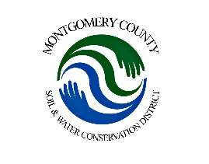
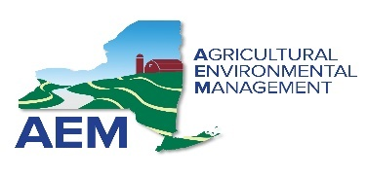

Funding Criteria

Scoring is based on the Proposal Rating Sheet. All proposals will then be ranked by their grand total score from highest to lowest for awards. The Montgomery County SWCD Board shall give preference to proposed projects that promote participation in or further the priorities of the AEM program and the specific five‐year AEM County Strategy.

Consideration will be given to the following factors in rating proposals:
- Project clearly addresses identified need or opportunity.
- Adequate scope of work and time frame.
- Project is cost effective.

State funding requests should be a maximum of $50,000. All BMPs must be designed and built to NRCS specifications. Preference points will be given to projects under $20,000 and towards projects with higher landowner contributions.

The Montgomery County SWCD will conduct site reviews of the proposed project areas as part of the selection process.

All eligible proposals will be scored against the stated rating criteria. The Montgomery County SWCD Board will rank each project for funding. The members of the Board, through adoption of a written resolution, will authorize funding for projects based on the ranking until the available funds are exhausted. The resolution shall be made available as part of the official meeting minutes. The Montgomery County SWCD shall notify in writing those farms selected for funding.

PROJECT APPLICATION FORM

Applicant:
Address
City State Zip Code
Email Phone Number

SPECIFIC PROJECT INFORMATION
Please complete the following to the best of your ability:

(project must be fully completed within a 2-year span to qualify)

- Has your farm been inventoried and assessed using the AEM Tier I and II process?
(If no, you are not eligible to receive financial assistance for this funding cycle. Please work with the staff at the SWCD to begin working through the AEM program.

- Has your farm received funding through the district before? If so, list practices installed.

- Has your farm completed, at a minimum, a conservation plan and/or nutrient management plan that addresses the practice you are applying to implement? Plans greater than 3 years old must be updated.

- List the watershed, stream or public drinking water supply this application will address? What is the distance of the resource concern (in linear feet) to the watercourse or well?

- Will this project repeat conservation practices? If yes, complete the below information.

Is the proposed conservation practice in the same location as the previously funded practice?

If Yes, how old is the practice?

- Is the planned BMP system intended to prevent pollution from farm expansion?

- Will this BMP take care of more than one pollution source from the farm?

- Is the BMP system needed to implement CNMPs for compliance with the SPDES Permit?

PROJECT NARRATIVE - Please describe the project, a problem statement that indicates the water quality concern to be addressed. Then provide a description of the how the BMP system will address the water quality concern described. Attach a detailed map of farmstead and planned practices as visual representation.

** Fill out a planned budget indicating your cost share portion and attach**

